Certificate of Match Postponement

Please forward via e-mail matthewpanting@btinternet.com
Within TWO days of the cancellation of the match (Sundays not included).
It is the duty of the HOME club to have informed the Match Officials,
their opponents, Fixtures Secretary, League Secretary, Referees Officers and the Website and Social Media Officer of the postponement without delay.
League Rule 14.2 will apply.

Match vs.
Match date Competition:
Name of appointed Match Referee:
Reason for the postponement and rule covering circumstances: |  |  | Identify areas of the field which are unplayable (where applicable):
 |  |  | 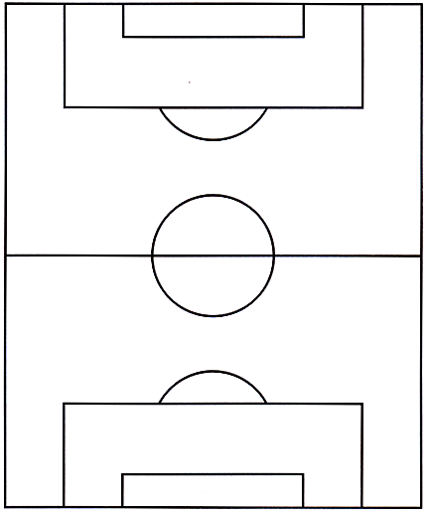
Name of inspecting Referee (where applicable – Must be on the SCEFL Panel & correct Level) |  |  | Signature
Date: |  |  | Time:
Name of Home Club Official & Position |  |  | Signature
Date: |  |  | Time:

