Actions to be conducted | Comments
Name and address of the affected setting | Croydon Football Club  Croydon Sports Arena  Albert Road  SE25 4QL
Contact details for manager/appropriate person (including name, position, telephone number and email) | CFC Management Board + Pete McCrann, Sally Meyer  Principal contact Mark Hudson, Chairman  07740640117 hudson_55@sky.com
Signed document displayed – Covid-19 secure | Displayed in Supporters Bar on Notice Board
Type of Building: | Classroom - Kinetic  Entertainment venue – Croydon FC/ Peter McCann (FM)  Office - Kinetic
Number of staff on site | Weekdays: Kinetic x 3  Evenings/Match days: CFC x 2  Events: 2
Layout of setting - floors/units / Rooms  (plan included in back pages of RA) | Entrance/Exit Main Gates  Entrance/Exit Lobby  Function Room  Kitchen  Porta-store  Gents Toilet  Ladies Toilet  Bar Office  Bar Walkway  Classroom (Kinetic)  Supporters Bar room  Patio  New Building Corridor (Kinetic)  NB Gents toilet (Kinetic)  NB Ladies Toilet (kinetic)  NB foyer (kinetic)  NB Main Office (Kinetic)  NB Boardroom (Kinetic)  Clubhouse Garden  Rear garden  Side walkway to Ryelands
Room types –  Entrance/Exit Main Gates | Staff (Responsible people for the site usage at any given time)  Visitors (*students/ footballers/ Away team/ Supporters, Event hire guests)  Cleaning – Maintained by Club Supportrs (Jason and Paul Davis)  Disinfect handrails/touched surfaces on matchdays  Kinetic on schooldays.  Signage : 2 m spacing/ one way/ people room limits/wash your hands /contactless payment  .
Entrance/Exit Lobby  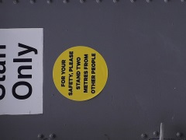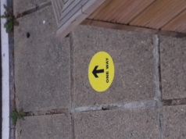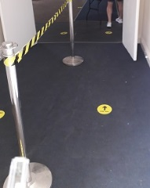 | Staff – One way system in place with segregation to reduce spread and contact.  Visitors – a/a  Cleaning – Daily as per cleaning regime  Signage –  2 Metres apart.  One way system in place.
Function Room  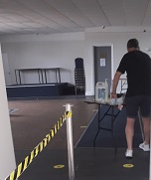 | Staff – sanitisation table contains products to reduce spread  One way system in place directs all visitors to take 2 options;  a) go to bar, b) go to Supporters area.  Doors are left open to avoid touch points  Visitors – a/a  Cleaning – Main responsibility of Peter and his team.  Signage – Directional on floor. Generic reminders to keep 2 Metres apart and wash hands.
Kitchen  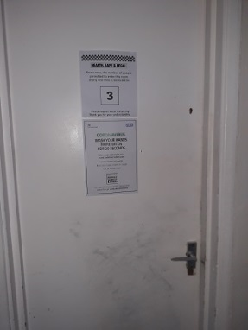 | Staff – 3 people allowed maximum.  Match day usage for Players meals. Function use as per hire agreements (upon Government approval to host events)  Washing machines taken out of action.  Visitors = out of bounds  Cleaning – See Peter FM Regime  Signage –  Max 3 people  Hand wash  Generic 2 Metre  Generic wash hands
Porta-cabin Storage  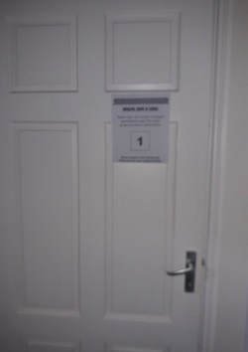 | Staff – 1 person at a time  Door is locked so limits user  Visitors – out of bounds  Cleaning – Touch points prior opening  Signage – 1 person maximum
Gents Toilet  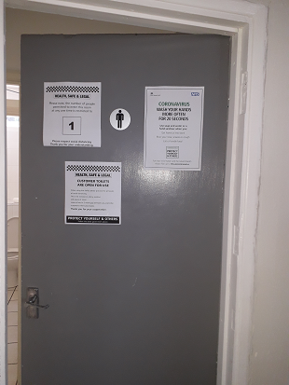 | Staff – 1 at a time  Visitors – a/a  Cleaning – prior and during usage periods to ensure disinfected.  Antibacterial provided  Hand towel dispenser installed  Signage  1 person per time  Wash hands
Ladies Toilet | Staff – 1 at a time  Visitors – a/a  Cleaning – prior and during usage periods to ensure disinfected.  Antibacterial provided  Hand towel dispenser installed  Signage  1 person per time  Wash hands
Bar Office  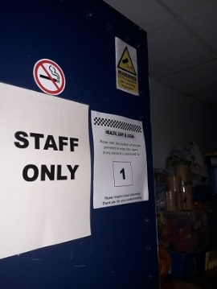 | Staff – 1 at a time  Visitors – Out of Bounds  Cleaning - FM  Signage –  1 per person maximum  Staff Only
Bar walkthrough | Staff – Bar staff have 2 x serving ‘places’ which are 2 meters apart. There are hand wash stations within the area. Both staff are related and cohabitate in ‘bubble’  Visitors – Out of Bounds  Cleaning - FM  Signage – generic 2 Metre rules poster
Classroom – Kinetic ONLY | Staff  Visitors  Cleaning  Signage
Supporters Bar Room | A one way system is in place taking users around the perimeter to the reduced tables available, and out to the rear exits to either pitch, garden or fire exit  The Fruit machine and Pool table are taken out of action to reduce spread  Sanitisation station will be set up for those entering from arena  Staff – Take visitors orders and leave on designated table for visitors to retrieve  Visitors – see above  Cleaning – FM Regime  Signage  One way floor signage  2 Metres reminders
Patio (Incl Wood store) | Taken out of bounds – Work required on floorboards  Staff  Visitors  Cleaning  Signage
New Building Corridor (Kinetic but used matchdays by CFC | Staff Kinetic-  CFC – Used for access and egress . Right hand side door for Exit Only, Left hand door to pitch and garden  Visitors – a/a  Cleaning – FM regine  Signage  Directional to services.  2 Metre rule reminders
New Building Foyer - Kinetic | Staff  Visitors  Cleaning daily  Signage in place
New Building Gents Toilet - Kinetic | Staff  Visitors  Cleaning daily  Signage in place
New Building Ladies Toilet - Kinetic | Staff  Visitors  Cleaning daily  Signage in place
New Building Office – Kinetic ONLY | Staff  Visitors = a/a  Cleaning - daily  Signage in place
New Building Boardroom - Kinetic | Staff  Visitors  Cleaning daily  Signage in place
Clubhouse Garden (Including entrance/exit to Arena track | Staff  Volunteers access via Rylenads side gate to avoid any contact within premises to maintain garden  Visitors – invite only  Cleaning  Signage  2 Metre floor signage on walkway
Rear Field (aka Petang) | Staff – Only used currently to remove garden waste by volunteers  Visitors – n/a  Cleaning – n/a  Signage – n/a
Side walkway/fire exit | Staff  Visitors  Cleaning  Signage
Cleaning Regime by FM | Cleaning – INSERT CLEANING PROCEDURE (example)  Daily (Event Days) and more regularly for touch points  - All desks to include surfaces, telephones, desk legs, mouse mat, computer stands  - Chairs including arm rests and legs  - Computers - keyboard, mice  - Doors including push plates, handles and glass  - Tables including legs  - Windowsills  - Fire extinguishers  - Light switches  Or Toilets  - All surfaces  - Sinks including taps, plug holes  - Soap dispensers  - Toilet including inside, toilet seat both sides, back of toilet, sides of toilet  - Flush handle/button  - Urinals tops and sides  - Toilet roll holders  - Sani bins  - Doors including push plates, handles and glass  - Cubicle doors including locks and handles  - Cubicle partition walls and tops of partitions  - Toilet brush fully clean including brush and container  - Hand driers including the underside and wall  - Light switches and sockets  - Skirting boards  - Ceiling vents  - Windowsills  - Cabinets including handles  - Mop floor fully including corners and edges  - Showers
Shared Facilities clients? Please provide details.
In line with Government guidelines | Offices: Working safety during Covid 19 HM Government guide (11 may 20)  Covid 19 – Guidance on re-starting Football activity for Providers of outdoor Football facilities incl Clubs (3 July 20)  Used FA guidelines to comply
Have there been any gatherings (informal / formal) held at the club within the last 72 hours? If yes:  - Nature of the event (indoor/outdoor)  - How many attendees (residents and/or visitors)  - Layout of the space | 8th and 9th August ‘Tidy up’ Event. Decorating to Kitchen and toilets as well as external grounds clearing and adding features.  Track and Trace in situ.  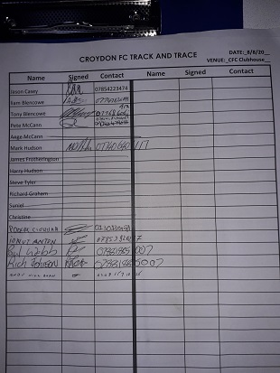
Hand hygiene
Are staff and residents familiar with hand and respiratory hygiene guidance?
Are posters displayed widely?
Are infection control policies up to date, read and followed by all staff?
Facilities  Is liquid soap and disposable paper towels available at each sink?  Is alcohol-based hand rub (at least 60%) in every room/communal area, and stocks adequately maintained?  (if it is not possible to have alcohol hand rub in rooms/communal areas, consider providing staff with individual containers).  What steps are being taken to reduce the risk of an outbreak for residents using shared facilities? | Please confirm actions taken and provide details where possible:  Staff-  Clients-
Personal protective equipment (PPE)  Has a risk assessment for PPE been undertaken and identified PPE available? Guidance can be found in the SOP. | Please confirm actions taken and provide details where possible: PPE risk assessment completed. Providence Row is supplying PPE to all staff and volunteers’ onsite – mask, gloves & hand sanitizer.
Linen and waste  Are linen management and clinical waste disposal systems in place, that align to national guidance (here)? | Washing machines taken out of action. Kit cleaned off site.
Are foot operated bins available in the Club? | Yes
Do staff wear appropriate PPE when cleaning an area where a person with possible or confirmed Covid-19 has been?
Is waste being disposed of appropriately?
Environmental cleaning  Are surfaces, and high touch areas cleaned frequently, including baths and showers?  Guidance can be found here. | All approved cleaning chemicals and COSHH on site.  Anti viral cleaning throughout and hi frequency touched surfaces cleaned regularly
Ventilation | Windows can be opened in all areas to encourage air circulation. Patio door and side doors at rear of clubhouse also a good source of regular air flow  .
Contractors Attendance management | Maintenance work is being is being scheduled to minimise the number of people onsite, and track and trace includes all contractors as well
Staff testing and wellbeing  Are staff aware of self-isolation advice as per guidance?  Are staff aware how they can access testing if symptomatic?  https://www.gov.uk/guidance/coronavirus-covid-19-getting-tested#arrange-a-test | Yes all staff advised
What steps have been taken to protect the physical health and wellbeing of your staff? | Please confirm actions taken and provide details where possible:  - Training and use of PPE to all staff and volunteers in line with PHE  - Morning update and afternoon briefing raising any concerns, Health and Safety issues, staff wellbeing.  - Incident reports and concerns with Management  - Reduce staffing onsite  - Reduced clients onsite  - Marking of safe distance on the floor  - Information sharing agreement between all main clubhouse users/managers.,
Managing an outbreak

Once the daycentre or PRHA has an outbreak, Public Health England (PHE) will offer support and collect information.
Croydon Football Club site users will need to inform PHE once they have one probable or confirmed cases within the premises

PHE will provide initial advice and support, along with local authority partners, to help Kinetic/CFC to manage the outbreak.

The club users will be expected to follow the outbreak control measures advised by PHE.

If you have 1 or more clients with symptoms of COVID-19 please contact the London Coronavirus Response Cell (LCRC) on 0300 303 0450 or LCRC@phe.gov.uk for public health advice. Please immediately inform LCRC on 0300 303 0450 if anyone dies, or if there is a large rise in the number of cases. The LCRC is also available for advice on implementing PHE guidance, if needed.

It is expected that PHE will complete a risk assessment like the one below.
Details of the outbreak (if applicable):
- Number of cases (residents and staff)
- Date of onset in first case
- Date of onset in most recent case
- Nature of symptoms and severity
- Any swabs already taken - obtain case details
- Any cases required admission to hospital
- Any staff affected
Total number of residents and staff in the entire hotel and the affected unit
Notes

Public Health England
If you have had at least one suspected case, please confirm you have contacted Public Health England and clarify what advice you received, date of advice, person spoken to and actions taken:
No suspected cases to date

This is the 5 Steps of Guiding Principles about managing the ‘return to work’
1. Define how many people is the workplace capacity ? This considers not just Social distancing but also access to lifts etc.. and minimising bottleneck situations. Perform Risk assessment of site following site inspection.
2. What is the Workplace strategy ?
3. Essential engagements and Communications with Staff
4. The ‘premises’ response to the new workplace strategy
The procuring/ issuing and storing of appropriate PPE (how is that defined ?), an increase in the cleaning regime, the reconfiguring of rooms and office areas to encourage social distancing, ensuring ‘compliant’ checks are performed before returning including mothballing of site, tests on HVAC (particularly ventilation), labelling on walkways of zones and lines to encourage safe distances.
The Testing of employees – The Antigen test. Displaying of Posters to encourage safe distancing. Provide sanitising stations
5. Staying flexible and being part of the leading of phased programmes;

