
SOUTHERN COUNTIES EAST FOOTBALL LEAGUE
MARKING OF REFEREES DIRECTIVE

Failure to comply with this Directive may result in the Club being charged for a breach of League Rule 4.8.
For reference under League rule 8.31 clubs must also submit a detailed report for a referee marked 60 or below via Moas for Premier division and Division 1 and FA Full Time for the development league within 3 days.

The mark awarded by a club must be based on the Referee’s overall performance. It is most important that the mark is awarded fairly and not based upon isolated incidents or previous games. The Referee’s performance should be determined by the table below which should act as a guide for the overall mark which should fall within the mark range for each standard of performance. A mark between 71 and 80 represents the standard of refereeing expected.
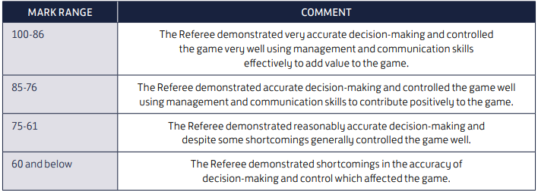

Notes
• Club officials should use the full range of marks within each category to help distinguish between different performance levels, e.g. within the 85-76 category a mark of 84 indicates a better performance than a mark of 77.
• While some Referees may have below average performances, there will usually have been some positive aspects of their performance, so extremely low marks should be very rare.
• When club officials are marking a Referee, they should always look at the game as a whole and not isolated decisions. The result of the match should not influence the mark and disciplinary action should be judged objectively.
• When a mark of 60 or lower is awarded, an explanation must be provided to the Competition using the box provided on the marking form. The purpose of this is to assist Referees to improve their performance levels, so the comments should be as helpful as possible.

HOW TO DECIDE ON THE REFEREE’S MARK
The following questions focus on the key areas of a Referee’s performance. They are intended as an “aide memoire”, are not necessarily comprehensive and need not be answered individually. It is, however, worth considering them before committing yourself to a mark for the Referee.

CONTROL AND DECISION MAKING
• How well did the Referee control the game?
• Were the players’ actions recognized correctly?
• Were the Laws applied correctly?
• Were all incidents dealt with efficiently/effectively?
• Were all the appropriate sanctions applied correctly?
Was the Referee always within reasonable distance of incidents?
• Was the Referee well positioned to make critical decisions, especially in and around the penalty area?
• Did the Referee understand the players’ positional intentions and keep out of the way accordingly?
• Did the Referee demonstrate alertness and concentration throughout the game?
• Did the Referee apply the use of the advantage to suit the mood and temperature of the game?
• Was the Referee aware of the players’ attitude to advantage?
• Did the Referee use the assistants effectively?
• Did the officials work as a team, and did the Referee lead and manage them to the benefit of the game?

COMMUNICATION AND PLAYER MANAGEMENT
• How well did the Referee communicate with the players during the game?
• Did the Referee’s Level of involvement/profile suit this game?
• Did the Referee understand the players’ problems on the day – e.g. difficult ground/weather conditions?
• Did the Referee respond to the changing pattern of play/mood of players?
• Did the Referee demonstrate empathy for the game, allowing it to develop in accordance with the tempo of the game?
• Was the Referee pro-active in controlling of the game?
• Was the Referee’s authority asserted firmly without being officious?
• Was the Referee confident and quick thinking?
• Did the Referee appear unflustered and unhurried when making critical decisions?
• Did the Referee permit undue questioning of decisions?
• Did the Referee deal effectively with players crowding around after decisions/incidents?
• Was effective player management in evidence?
• Was the Referee’s body language confident and open at all times?
• Did the pace of the game, the crowd or player pressure affect the Referee negatively?

FINAL THOUGHTS
• Always try to be objective when marking. You may not obtain the most objective view by marking immediately after the game.
• Judge the performance over the whole game. Don’t be too influenced by one particular incident.
• Don’t mark the Referee down unfairly because your team was unlucky and lost the game or some disciplinary action was taken against your players.

